Bài 1: Công trừ nhân chia 2 phân số

* Code:
* class PhanSo
* @tuso
* @mauso
* attr_accessor :tuso,:mauso
* def initialize(tuso,mauso)
* @tuso = tuso
* @mauso = mauso
* end
* def timUSCLN(a, b)
* while (a != b)
* if (a > b)
* a -= b
* else
* b -= a
* end
* end
* return a
* end
* def congPS(phanso_2)
* tu_plusOperator = @tuso * phanso_2.mauso + phanso_2.tuso * @mauso
* mau_plusOperator = @mauso * phanso_2.mauso
* @ucln = timUSCLN(tu_plusOperator,mau_plusOperator)
* p ("Tong 2 PS la: #{tu_plusOperator/@ucln} / #{mau_plusOperator/@ucln}")
* end
* def truPS(phanso_2)
* tu_subtractOperator = @tuso * phanso_2.mauso - phanso_2.tuso * @mauso
* mau_subtractOperator = @mauso * phanso_2.mauso
* @ucln = timUSCLN(tu_subtractOperator.abs(),mau_subtractOperator)
* p ("Hieu 2 PS la: #{tu_subtractOperator/@ucln} / #{mau_subtractOperator/@ucln}")
* end
* def nhanPS(phanso_2)
* tu_multiOperator = @tuso * phanso_2.tuso
* mau_multiOperator = @mauso * phanso_2.mauso
* @ucln = timUSCLN(tu_multiOperator,mau_multiOperator)
* p ("Tich 2 PS la: #{tu_multiOperator/@ucln} / #{mau_multiOperator/@ucln}")
* end
* def chiaPS(phanso_2)
* tu_divisionOperator = @tuso * phanso_2.mauso
* mau_divisionOperator = @mauso * phanso_2.tuso
* @ucln = timUSCLN(tu_divisionOperator,mau_divisionOperator)
* p ("Thuong 2 PS la: #{tu_divisionOperator/@ucln} / #{mau_divisionOperator/@ucln}")
* end
* end
* def checkZero(num)
* if num == 0
* return true
* end
* return false
* end
* p('--------Nhap phan so thu nhat-------')
* print('Nhap tu so: ')
* ts1 = gets.to_f
* while (true)
* print('Nhap mau so: ')
* ms1 = gets.to_f
* if(checkZero(ms1) == true)
* p "Mau so phai khac 0"
* else
* break
* end
* end
* p('--------Nhap phan so thu 2-------')
* print('Nhap tu so: ')
* ts2 = gets.to_f
* print('Nhap mau so: ')
* while (true)
* print('Nhap mau so: ')
* ms2 = gets.to_f
* if(checkZero(ms2) == true)
* p "Mau so phai khac 0"
* else
* break
* end
* end
* phanso_1 = PhanSo.new(ts1,ms1)
* phanso_2 = PhanSo.new(ts2,ms2)
* phanso_1.congPS(phanso_2)
* phanso_1.truPS(phanso_2)
* phanso_1.nhanPS(phanso_2)
* phanso_1.chiaPS(phanso_2)
* Kết quả:

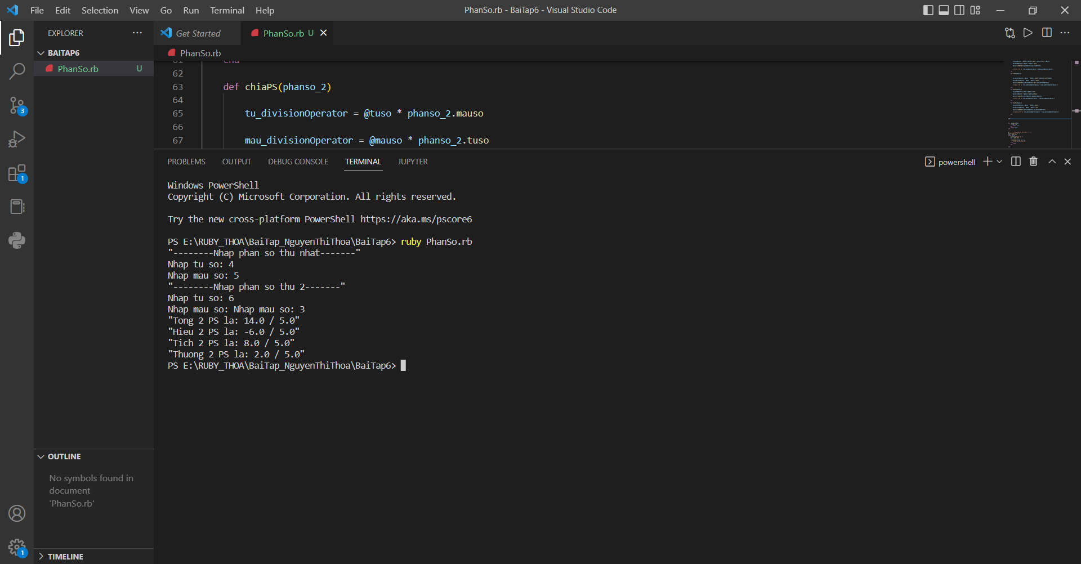

Bài 2 : Overloading:

* Code:
* class PhanSo
* attr_accessor :tuso,:mauso
* def initialize(tuso,mauso)
* @tuso = tuso
* @mauso = mauso
* end
* def timUSCLN(a, b)
* while (a != b)
* if (a > b)
* a -= b
* else
* b -= a
* end
* end
* return a
* end
* def +(phanso_2)
* tu_plusOperator = @tuso * phanso_2.mauso + phanso_2.tuso * @mauso
* mau_plusOperator = @mauso * phanso_2.mauso
* @ucln = timUSCLN(tu_plusOperator,mau_plusOperator)
* return ("Tong 2 PS la: #{tu_plusOperator/@ucln} / #{mau_plusOperator/@ucln}")
* end
* def -(phanso_2)
* tu_subtractOperator = @tuso * phanso_2.mauso - phanso_2.tuso * @mauso
* mau_subtractOperator = @mauso * phanso_2.mauso
* @ucln = timUSCLN(tu_subtractOperator.abs(),mau_subtractOperator)
* return ("Hieu 2 PS la: #{tu_subtractOperator/@ucln} / #{mau_subtractOperator/@ucln}")
* end
* def *(phanso_2)
* tu_multiOperator = @tuso * phanso_2.tuso
* mau_multiOperator = @mauso * phanso_2.mauso
* @ucln = timUSCLN(tu_multiOperator,mau_multiOperator)
* return ("Tich 2 PS la: #{tu_multiOperator/@ucln} / #{mau_multiOperator/@ucln}")
* end
* def /(phanso_2)
* tu_divisionOperator = @tuso * phanso_2.mauso
* mau_divisionOperator = @mauso * phanso_2.tuso
* @ucln = timUSCLN(tu_divisionOperator,mau_divisionOperator)
* return ("Thuong 2 PS la: #{tu_divisionOperator/@ucln} / #{mau_divisionOperator/@ucln}")
* end
* end
* def checkZero(num)
* if num == 0
* return true
* end
* return false
* end
* p('--------PHAN SO I--------')
* print('Nhap tu so: ')
* ts1 = gets.to_f
* while (true)
* print('Nhap mau so: ')
* ms1 = gets.to_f
* if(checkZero(ms1) == true)
* p "Mau so phai khac 0"
* else
* break
* end
* end
* p('--------PHAN SO II--------')
* print('Nhap tu so: ')
* ts2 = gets.to_f
* print('Nhap mau so: ')
* while (true)
* print('Nhap mau so: ')
* ms2 = gets.to_f
* if(checkZero(ms2) == true)
* p "Mau so phai khac 0"
* else
* break
* end
* end
* phanso1 = PhanSo.new(ts1,ms1)
* phanso2 = PhanSo.new(ts2,ms2)
* p phanso1+phanso2
* p phanso1-phanso2
* p phanso1*phanso2
* p phanso1/phanso2
* Kết quả:

